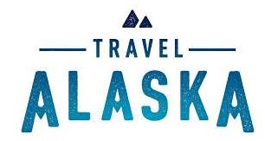

**Travel Alaska Membership Co-Op Packages**

ATIA is excited to introduce three Co-Op Packages, designed to make advertising with Travel Alaska easy, effective, and affordable, all at a discounted rate for members.

Below are the programs included within each package. They come as is, and no program can be substituted or changed.

**Package 1 - $1,500**

2 Featured Profile Ads, 1 Travel Special, 1 Opt-In Leads

Total Value: $1,800

**Package 2 - $5,000**

5 Featured Profile Ads, 2 Travel Specials, 2 Banner Ads, 1 Sponsored Content, 1 Opt-In Leads

Total Value: $6,200

**Package 3 - $10,000**

7 Featured Profile Ads, 3 Travel Specials, 4 Banner Ads, 1 Sponsored Content, 1 Opt-In Leads, 2 Integrated Ads, 1 Secondary E-Newsletter

Total Value: $13,000

If you're an ATIA member and are interested in purchasing a package, please contact [advertising@alaskatia.org](mailto:advertising@alaskatia.org).

If you are not a member, but would like to become one, please contact [membership@alaskatia.org](mailto:membership@alaskatia.org).